A PROJECT REPORT

HOSPITAL MANAGEMENT SYSTEM

Submitted by

Muruganatham J (610715104024)

In partial fulfilment for the award of the degree

of

BACHELOR OF ENGINEERING

IN

COMPUTER SCIENCE AND ENGINEERING

GOVERNMENT COLLEGE OF ENGINEERING

BARGUR-635 104

ANNA UNIVERSITY:CHENNAI - 600 025

SEPTEMBER 2016

ANNAUNIVERSITY:CHENNAI- 600025

BONAFIDE CERTIFICATE

Certified that this project report **“HOSPITAL MANAGEMENT SYSTEM”** is the bonafide work of“ Hemalatha R (610715104011), Jamuna R (610715104012), Kavitha M(610715104013), Muruganatham J(610715104024), Sivaranjini R(610715104046), Soniya D(610715104047), Sowmiya S(610715104048), Sridhar U(610715104049)” who carried out the project work under my supervision.

**SIGNATURE SIGNATURE**

**Dr.J.NAFEESA BEGAM,Ph.D., K.SARIDHA, M.E,**

**HEAD OF THE DEPARTMENT, ADHOC FACULTY,**

Computer Science and Engineering, Computer Science and Engineering,

Government College of engineering, Government College of Engineering,

Bargur- 635 104. Bargur-635104.

Submitted for the Anna University Project Work Viva Voice Examination held on

**INTERNAL EXAMINER EXTERNAL EXAMINER**

**ABSTRACT**

Our project Hospital Management System includes registration of patients, storing their details into the system, and also computerized billing in the pharmacy, and labs. Our software has the facility to give a unique id for every patient and stores the details of every patient automatically. The Hospital Management System can be entered using a username and password. It includes a search and view facility to know the current status of each patients. User can search availability of the details of a patient using the id and the disease.

**Introduction**

Virtual Basic is a third generation event-driven programming language and integerated development environment(IDE) from Microsoft for its Component Object Model(COM) programming model first released in 1991 and declared legacy in 2008. It is a programming environment from Microsoft in which a programmer uses a graphical user interface(GUI) to choose and modify preselected sections of code in BASIC programming language.Hospital Management VB project compleex project has the scope of adding new entries.it consist of several interfaces which include Welcome Login interface,entry interface,view interface,search interface,outpatient interface and Services interface.In welcome interface,it includes just progressing ,initimates that the administrator is getting in the management program.In login interface ,we provide authorization to the user getting in.The multiple document interface ,provides base screen for all management program actions present in the management program.We can search aa patients by his id and then view his details.

**SYSTEM SPECIFICATION**

**Hardware Requirements**

* Pentium-4(processor)
* 256 MB RAM
* 512 KB Cache Memory
* Hard disk 10 GB
* Microsoft compatible 101 or more key Board

**Software Requirements**

* Operating system : windows
* Front-End : Visual Basic
* Back-End : MS-Access

**Use Case**

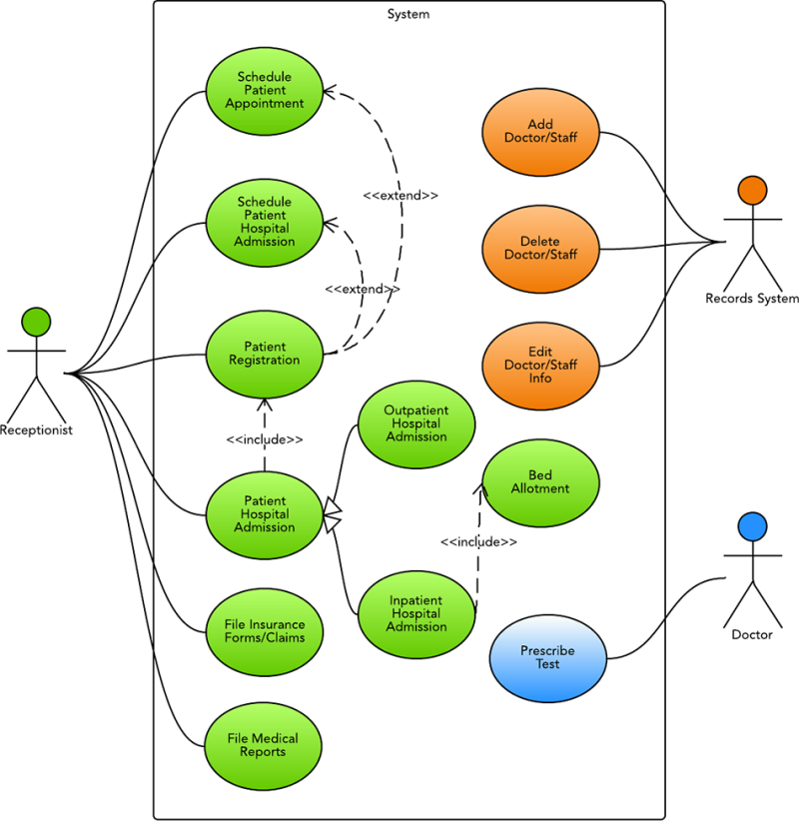

The process of getting medical attention can be confusing.Hospital administrators can improve the experience by using diagrams to chart relevant details.For example,this use case diagram for hospital management system(UML) shows how the receptionist,records system, and doctor work together to the insurance claims,prescribe tests, schedule patient appointments, and much more.To make a use case diagram in lucidchart, you can simply drag and drop elements on to the canvas and rearrange as necessary.

**Flow chart**

Manage all

Admin login

Details

Patient details

New patient entry

Reports

management

Search patients

View patients

search patients details

A flowchart is a formalized graphic representation of a logical sequence, work or manufacturing process, organization chart, or similar formalized structure.The purpose of flow chart is to provide people with a common language or reference point when dealing with a project or process.

**ER DIAGRAM OF PATIENT DETAILS**

Add(patient)

Search

patient

New patient

login

ISA

Hospital management system illustrated with entity relationship diagram template with entities and attributes.This entity relationship diagram was made with creately,diagramming and collaboration software.Creately helps you draw beautiful diagrams really fast.

**PATIENT DATABASE USING VB**

**Form 1**

Private Sub Command1_Click()

Dim a As Boolean

a = False

If (Text1.Text = "hospital" And Text2.Text = "hos") Then

a = True

Form2.Show

Unload Me

End If

If (a = False) Then

MsgBox ("Enter Correct Username and Password")

End If

End Sub

**Form 2**

Private Sub Command1_Click()

Form3.Show

Unload Me

End Sub

Private Sub Command2_Click()

Form4.Show

Unload Me

End Sub

Private Sub Command3_Click()

Form5.Show

Unload Me

End Sub

Private Sub Command4_Click()

Unload Me

End Sub

Private Sub Form_Load()

End Sub

**Form 3**

Private Sub Command1_Click()

Dim cn As New ADODB.Connection

Dim rs As New ADODB.Recordset

cn.Open "dsn=Software"

rs.ActiveConnection = cn

With rs

.CursorType = adOpenStatic

.CursorLocation = adUseClient

.LockType = adLockOptimistic

.Open "select * from Details"

End With

With rs

.AddNew

.Fields(0) = Val(Text1.Text)

.Fields(1) = Text2.Text

If (Option1 = True) Then

.Fields(2) = Option1.Caption

End If

If (Option2 = True) Then

.Fields(2) = Option2.Caption

End If

.Fields(3) = Val(Text3.Text)

.Fields(4) = Text4.Text

.Fields(5) = Text5.Text

.Fields(6) = Text6.Text

.Update

End With

Text1.Text = ""

Text2.Text = ""

Text3.Text = ""

Text4.Text = ""

Text5.Text = ""

Text6.Text = ""

Option1 = False

Option2 = False

End Sub

Private Sub Command2_Click()

Form2.Show

Unload Me

End Sub

Private Sub Form_Load()

End Sub

**Form 4**

Private Sub Command1_Click()

Dim cn As New ADODB.Connection

Dim rs As New ADODB.Recordset

Dim a As Boolean

a = False

cn.Open "dsn=software"

rs.ActiveConnection = cn

With rs

.CursorType = adOpenStatic

.CursorLocation = adUseClient

.LockType = adLockOptimistic

.Open "select * from Details"

End With

rs.MoveFirst

While Not rs.EOF

If (Val(Text1.Text) = rs(0)) Then

Text3.Text = Text3.Text + rs(1) + ", "

Text3.Text = Text3.Text + rs(2) + ", "

Text3.Text = Text3.Text + Str$(rs(3)) + ", "

Text3.Text = Text3.Text + rs(4) + ", "

Text3.Text = Text3.Text + rs(5) + ", "

Text3.Text = Text3.Text + rs(6) + ", "

a = True

End If

rs.MoveNext

Wend

If (a = False) Then

MsgBox ("Enter correct Employee ID")

End If

Text1.Text = ""

End Sub

Private Sub Command2_Click()

Dim cn As New ADODB.Connection

Dim rs As New ADODB.Recordset

Dim a As Boolean

a = False

cn.Open "dsn=software"

rs.ActiveConnection = cn

With rs

.CursorType = adOpenStatic

.CursorLocation = adUseClient

.LockType = adLockOptimistic

.Open "select * from Details"

End With

rs.MoveFirst

While Not rs.EOF

If (Text2.Text = rs(4)) Then

Text3.Text = Text3.Text + Str$(rs(0)) + ", "

Text3.Text = Text3.Text + rs(1) + ", "

Text3.Text = Text3.Text + rs(2) + ", "

Text3.Text = Text3.Text + Str$(rs(3)) + ", "

Text3.Text = Text3.Text + rs(5) + ", "

Text3.Text = Text3.Text + rs(6) + ". "

a = True

End If

rs.MoveNext

Wend

If (a = False) Then

MsgBox ("Enter correct Designation")

End If

Text2.Text = ""

End Sub

Private Sub Command3_Click()

Form2.Show

Unload Me

End Sub

Private Sub Form_Load()

End Sub

**Form 5**

Private Sub Command1_Click()

Dim cn As New ADODB.Connection

Dim rs As New ADODB.Recordset

Dim a As Boolean

a = False

cn.Open "dsn=software"

rs.ActiveConnection = cn

With rs

.CursorType = adOpenStatic

.CursorLocation = adUseClient

.LockType = adLockOptimistic

.Open "select * from Details"

End With

rs.MoveFirst

While Not rs.EOF

If (Val(Text1.Text) = rs(0)) Then

Text2.Text = rs(1)

Text3.Text = rs(2)

Text4.Text = rs(3)

Text5.Text = rs(4)

Text6.Text = rs(5)

Text7.Text = rs(6)

a = True

End If

rs.MoveNext

Wend

If (a = False) Then

MsgBox ("Enter correct ID")

End If

End Sub

Private Sub Command2_Click()

Form2.Show

Unload Me

End Sub

Private Sub Form_Load()

End Sub

**1.TO CREATE LOGIN FORM**

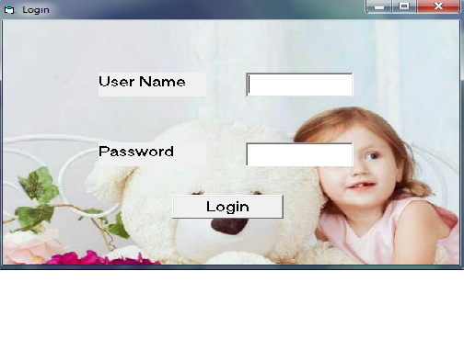

**2.TO DISPLAY PATIENT DETAILS**

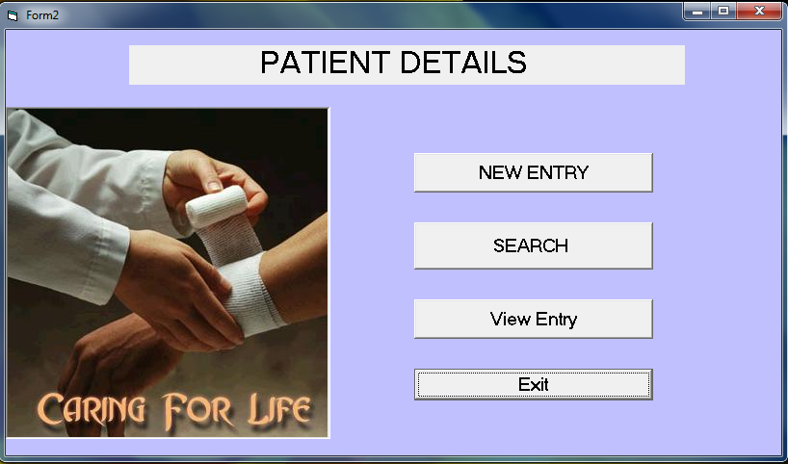

**3.TO ADD PATIENT DETAILS**

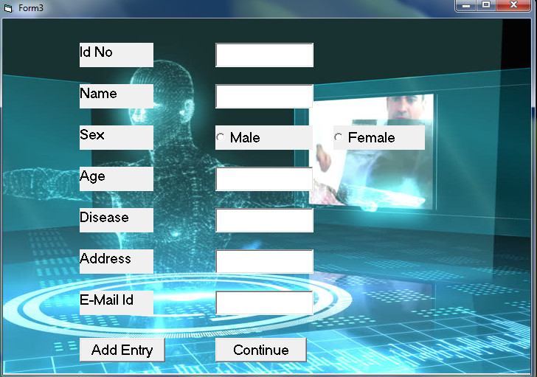

**4.TO SEARCH PATIENT DETAILS**

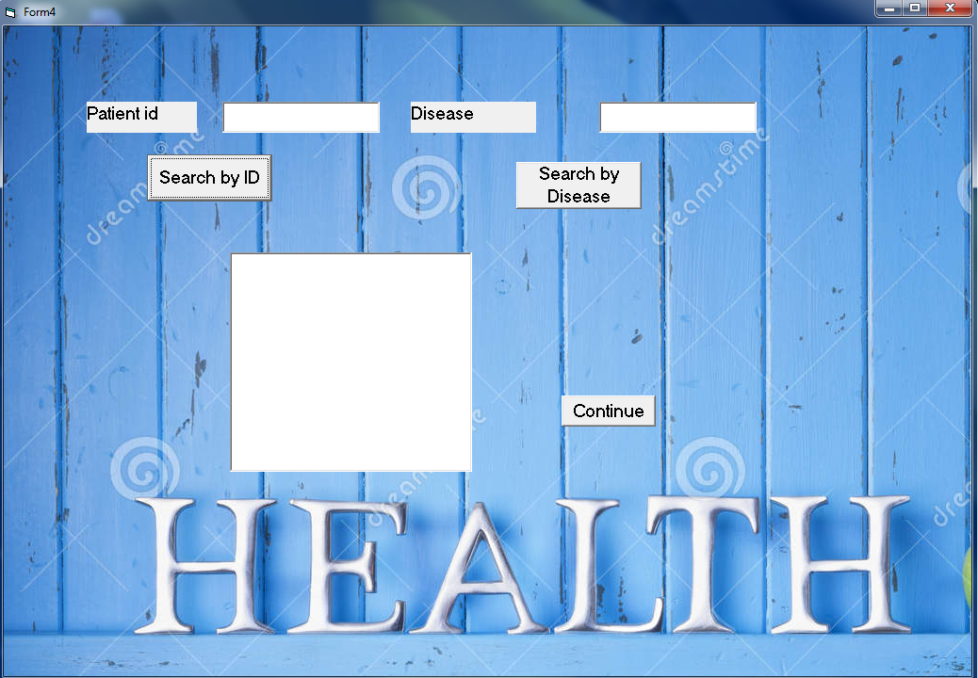

**5.TO VIEW PATIENT DETAILS**

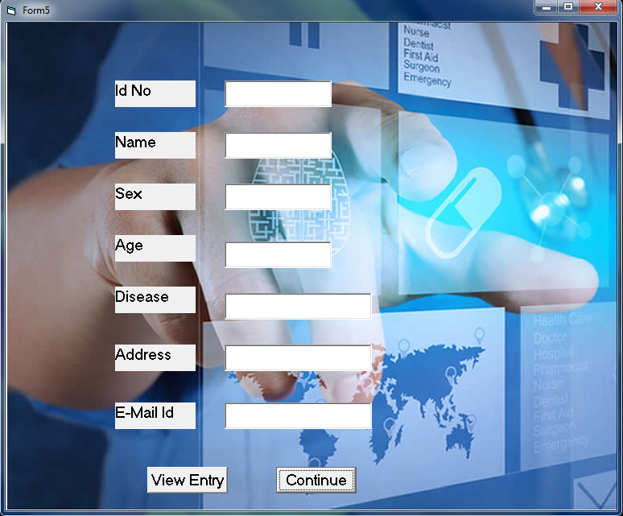

**CONCLUSION**

The project Hospital mangement system is for computerzing the working in a hospital.The software takes care of all the requirements of an average hospital and is capable toprovide easy and effective storage of information related to patients the come up to the Hospital.The system can also provide the information about the patients using search and View patients operations.A major positive of using Visual Basic is the speed at whichapplications can be developed for it.It is also quite useful as a front-end language forprogramming interactivity with databases.A major disadvantage of using Visual basic is that as a Microsoft Proprietary language, its compatibility with non-microsoft systems is limited.